***Unicom Management System***

1. **Project over view(Point-Wise)**

* **Purpose-**

**To build a desktop-based management system for Unicom tutorial to handle Student lecture enrollment , class and exam scheduling, marks management and staff management.**

* **Key features implemented.**
* **Admin login for secure access.**
* **Role access system.**
* **Username &Password Login system.**
* **Student registration and Class assignment .**
* **Lecture registration.**
* **Course and Subject Schedule.**
* **Timetable scheduling(Group,Date,Time,lecture..).**
* **Technologies used.**

**Frontend- Winform(C#).**

**Backend- SQLite**

**IDE- Visual studio**

**Tools-DB Browser for SQLite,GitHub.**

* **Challenges**

**Password Management:**

**Timetable schedule:**

**Role based access:**

1. 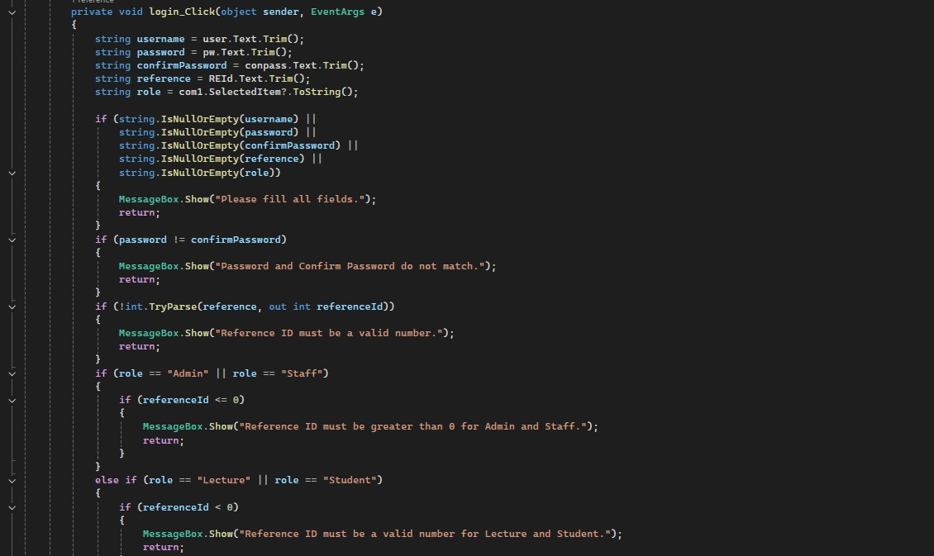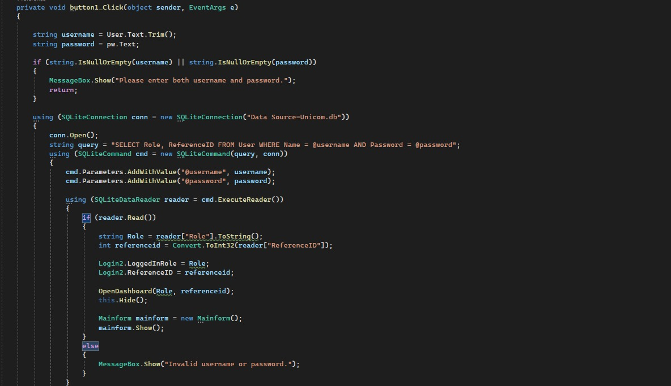**Code samples(Screenshots)**

**1.Sign up coding**

**3. Role checking**

1. 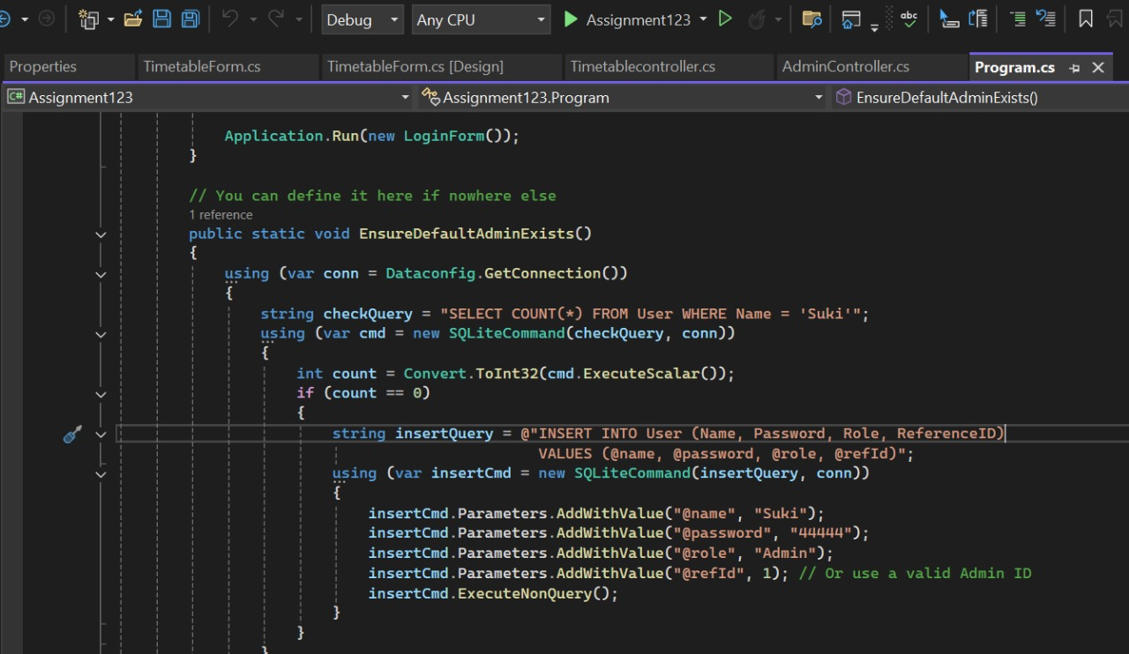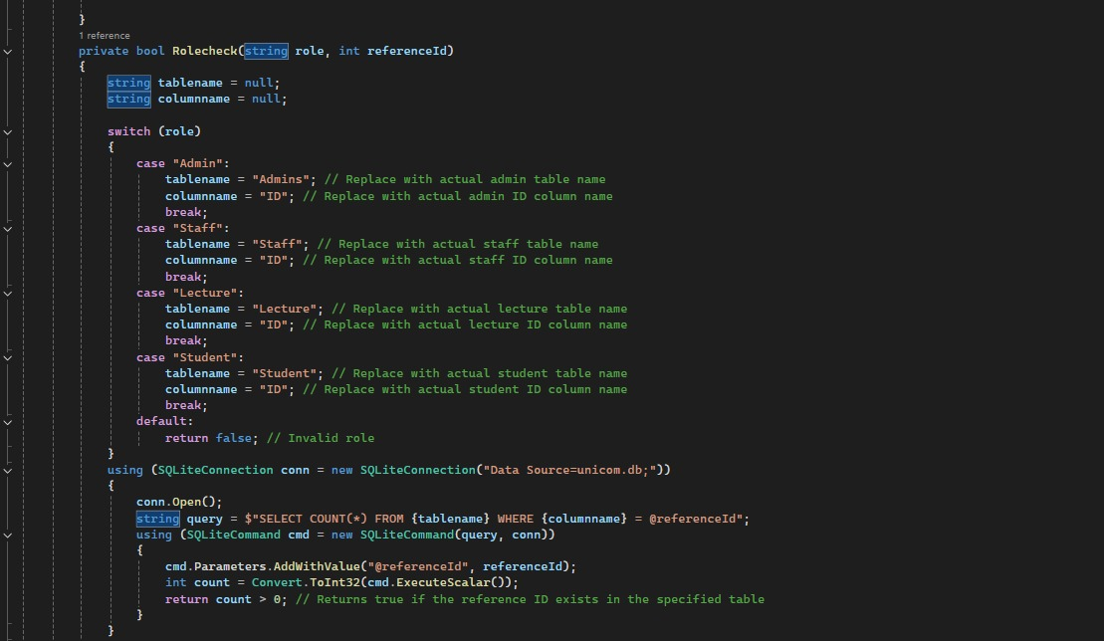 **Permanent Password for admin.**